**VMware Horizon on Azure deployment guide**

Rev 2.1 Niall Currid

# Purpose

The purpose of this guide is to setup and deploy Horizon Cloud on Azure using WVD to rapidly enable our customers to provide work from home desktops via Windows 10 Enterprise Virtual Desktop.

This guide does not cover application group provisioning of specific on integration with profile management, such as FSLogix, which is extensively documented.

# Pre-Requisites and Important Considerations

1. Begin by reviewing the prerequisites and requirements document [here](https://docs.vmware.com/en/VMware-Horizon-Cloud-Service/services/hzncloudmsazure.getstarted15/GUID-5F69086E-E061-48F3-93D9-9705B8B5FD8A.html)
2. Important Azure considerations prior to deployment:

**Important:** Before launching the pod deployment wizard and starting to deploy your pod, in addition to the requirements below, you must be aware of the following key points:

1. No Microsoft Azure Policies or Policy Definition configured in the Microsoft Azure environment block, deny, or restrict creation of the pod's components. As an example, you and your IT team must verify that none of your Microsoft Azure Policies block, deny, or restrict creation of components on Azure storage account. For information about Azure Policies, see the [Azure Policy documentation](https://docs.microsoft.com/en-us/azure/governance/policy/).
2. The pod deployer requires that your Azure storage account allow for the deployer to use the Azure StorageV1 account type. Ensure that your Microsoft Azure Policies do not restrict or deny the creation of content requiring the Azure StorageV1 account type.
3. As part of the pod and gateway deployment processes, Horizon Cloud creates resource groups (RGs) in your Microsoft Azure subscription that do not have tags on them, including the initial resource group that is created for the temporary jump box that orchestrates those deployment processes. Pod deployment will fail if you try to deploy a pod into a Microsoft Azure subscription that has any type of resource tag requirement at the time of deployment, or at the time of pod upgrades or adding a gateway configuration to a pod.   
     
   You must verify that your Microsoft Azure Policies allows creation of the pod's untagged resource groups in the target subscription. For the list of RGs that the deployer creates, see the Administration Guide's [Resource Groups Created For a Pod Deployed In Microsoft Azure](https://docs.vmware.com/en/VMware-Horizon-Cloud-Service/services/hzncloudmsazure.admin15/GUID-9F004F77-5685-400E-8ADC-3ECA96D3CA71.html" \t "_blank) topic.
4. All cloud-connected pods must have line-of-sight to the same set of Active Directory domains at the time you deploy those pods.

## During a typical deployment, you can expect the following resources to be deployed:

Minimum Microsoft Azure capacity available for Horizon Cloud infrastructure in addition to the expected desktop and app workload. Note that as long as this capacity is made available, Horizon Cloud will automatically deploy these VMs and no manual installation is required.

* Pod Deployment Engine, also known as the Jump Box (transient) — 1 x Standard\_F2
* Pod/Pod Manager with High Availability enabled — 2 x Standard\_D4\_v3 (if no Standard\_D4\_v3 in the region, 2 x Standard\_D3\_v2)
* Pod/Pod Manager without High Availability enabled — 1 x Standard\_D4\_v3 (if no Standard\_D4\_v3 in the region, 1 x Standard\_D3\_v2)
* Microsoft Azure Database for PostgreSQL Service — Generation 5, Memory Optimized, 2 vCores, 10 GB Storage
* External Unified Access Gateway (optional) — 2 x Standard\_A4\_v2

Internal Unified Access Gateway (optional) — 2 x Standard\_A4\_v2

## Requirements for deployment

1. Three non-overlapping address ranges in CIDR format in the pod's VNet, reserved for subnets.

* Management subnet — /27 minimum
* Tenant subnet — /27 minimum /24 - /22 preferred, based on the number of desktops and RDS servers
* DMZ subnet — /28 minimum when Unified Access Gateway is deployed in the pod's VNet (optional)

*Subnets can either be created manually on the VNet or by Horizon Cloud during deployment. If using manually created subnets, no other resources can be attached.*

1. NTP server or servers available and accessible from the Horizon Cloud pod and Unified Access Gateway instances.
2. Configure the VNet (Virtual Network) DNS server, pointing to a valid DNS server that can resolve both internal machine names and external names.
3. Outbound internet access on the VNet to specific DNS names that must be resolvable and reachable using specific ports and protocols.
4. FQDN for external and or internal user access (Required when deploying a pod with Unified Access Gateway).
5. Certificate or certificates for Unified Access Gateway in PEM format matching the FQDN
6. Service principal and authentication key created for each subscription with contributor role assigned on the subscription.
7. Required resource providers registered in each Microsoft Azure subscription. See step 8.b in [Create the Required Service Principal Needed by the Horizon Cloud Pod Deployer by Creating an Application Registration](https://docs.vmware.com/en/VMware-Horizon-Cloud-Service/services/hzncloudmsazure.getstarted15/GUID-DC011997-CE9E-4B38-9C4F-57104226218C.html" \t "_blank).

# Architecture Overview

In a typical deployment of HCoA, these are the components:

Begin Deployment

1. Log into the Horizon Cloud Portal:
   1. [VMware Horizon portal](https://cloud.horizon.vmware.com/login2/login?redirect_uri=%2Fhorizonadmin%2F%23%2Flogin)
   2. *If you do not have an account, signup [here](https://www.vmware.com/horizon-cloud-on-microsoft-azure-trial.html) for a 45 day trial*
2. After logging in successfully, you will receive the following screen:

# Add Capacity

1. Select the ADD button to the right, and you will be prompted to select the cloud – (Please) Select Azure

1. Next, you’ll be prompted for your subscription details, Azure AD Tenant ID and the application ID that you setup in the prerequisites. Complete all fields and click ADD.

1. Complete the POD setup fields:

1. Complete the UAG Setup. Refer to [here](https://docs.vmware.com/en/VMware-Horizon-Cloud-Service/services/hzncloudmsazure.getstarted15/GUID-97521A2A-689A-4D05-9123-E020E967E679.html) for more informatio on UAG deployment considerations.

**The certificate has to be in PEM format**

1. After you complete these fields, you will see a summary of information. Click submit to proceed with the deployment. This phase will take approx. 10-15 minutes.
2. After the Azure POD is successfully created, move onto configure Active Directory. Click on configure beside Active Directory in the main window. Complete the fields. Note, you should have your DNS properly setup on your vNet prior to this step.

1. Once the domain bind is successful, you will be prompted for a Domain Join Account. This account is for joining your provisioned Windows Systems to your domain. This account should have the following privileges:

Domain join account

1. Active Directory domain join account which can be used by the system to perform Sysprep operations and join computers to the domain, typically a new account (domain join user account)
2. Is a member of the Horizon Cloud Administrators Group
3. Set account password to Never Expire
4. This account requires the following Active Directory permissions: List Contents, Read All Properties, Read Permissions, Reset Password, Create Computer Objects, Delete Computer Objects.
5. This account also requires the Active Directory permission named Write All Properties on all descendant objects of the target Organizational Unit (OU) that you plan to use for farms and VDI desktop assignments.
6. For additional details and requirements, see [Service Accounts That Horizon Cloud Requires for Its Operations](https://docs.vmware.com/en/VMware-Horizon-Cloud-Service/services/hzncloudmsazure.admin15/GUID-5F0B52F6-CD79-447B-B1C6-6ED2AF71BBA7.html" \t "_blank)

1. Add the Horizon Administrator Group:

Active Directory groups

* Horizon Cloud Administrators — Active Directory security group for Horizon Cloud administrators. Contains the Horizon Cloud administrative users and domain join account. This group is added to the Super Administrators role in Horizon Cloud.

1. At this point you should have completed the General Setup stage, and have a screen as follows:

# Desktop Assignment

1. This phase of the deployment completes the following tasks:
   1. Imports a VM
   2. Allows for preparation & customization of the image
   3. Creation of an image for your VDI/RDSH systems
   4. Creates a Desktop farm for your PODs/Users to consume
2. On Import VM, click ADD to begin

1. You will have the option to Import a Virtual Machine or Import a Windows OS Virtual Machine from the marketplace, which will automatically be configured with the Horizon Cloud Agents.

To creating Desktop Images for a Horizon Cloud Pod in Microsoft Azure, see:

<https://docs.vmware.com/en/VMware-Horizon-Cloud-Service/services/hzncloudmsazure.admin15/GUID-D090D2ED-6446-4544-BEEC-D01F60F1F62B.html>

1. For this deployment, I will select an image from the Marketplace.

* 1. Select an OS – I have selected Windows 10 Multisession 1909 with Office
  2. Options for GPU (if available in your selected region)
  3. Domain Join – Select this option if it is your finalized image for Pod Deployment only.
  4. Enable Public IP – for RDP access to machine for customizations.
  5. Optimize Windows Image – details [here](https://docs.vmware.com/en/VMware-Horizon-Cloud-Service/services/hzncloudmsazure.admin15/GUID-B6C49A99-0A72-418C-87DD-5C7751E7C951.html)
  6. Admin Credentials for the VM, Create the admin username that will be used for the local admin account to access the VM's operating system, and also used during the convert to image process. This username can be a maximum of 15 characters in length, cannot end in a full stop (".") and cannot be a username that is not permitted in Microsoft Azure, like "guest" or "administrator".
  7. Properties - Give a unique name to the desktop that will be used to create an image. This image will be used as the operating system on the virtual desktops.
  8. Here is a list of Windows OS Images available as of writing this:

* 1. Here is a list of the advanced options that you can enable:

1. Once the import process has completed, you can click Go to proceed with image customization.

1. You should now be presented with an imported VM with an agent status of Active. If its not active, select the VM and from the MORE menu, select “Reset Agent Pairing”

1. At this point now, you can login to this imported VM and begin your customizations. When you have completed your customizations, return to the main deployment menu (Settings > Getting Started). Leave the machine powered on, as the next step (Create Image) requires the VM to be powered on.
2. The next step is the Create an image. Click on Create Image > New

1. Complete the required fields for the new image.

1. Click Publish when complete. This process can take up to 10 minutes.
2. You can monitor the status of these tasks and jobs by going to Monitor > Activity

1. Create Desktop Farm – Create a farm of virtual machines that will be used to provision desktops.

1. Select New on Create Desktop Farm, you will be presented with the following:

* 1. Name: A friendly name for the farm and provide a description.
  2. VM Names: This is where you can provide a naming convention for your VMs which will be numerically incremented. Try to keep this under 15 characters.
  3. Farm Type: Select application or Desktops.
  4. Filter Models: This allows you to filter for a specific VM type. I have selected a B series for reduced costs.
  5. The next few options are pre-completed for you, please read [this](https://docs.vmware.com/en/VMware-Horizon-7/7.5/horizon-architecture-planning/GUID-CFAABEB9-9CF2-4098-A01D-1CA118D4B6BD.html) if you are not familiar with VMware’s Display Protocols
  6. Complete the remaining fields.

1. Management, setting the maintenance and timeout handling on the farmA screenshot of a cell phone

   Description automatically generated
2. Click next to see a summary and submit to create the farm. This step can take up to 30 minutes.
3. The final step is to assign users to the desktop farm. Select New to continue.

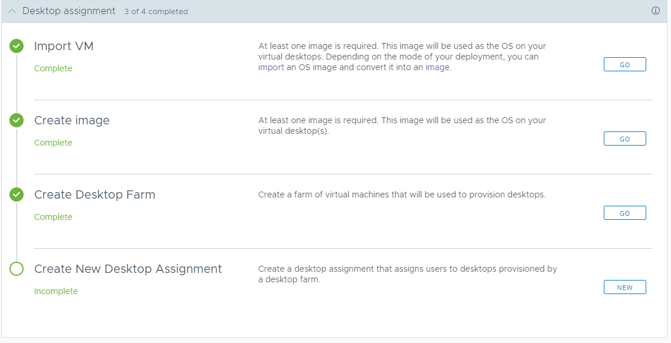

1. Assign Desktops. There are three options to consider:
   1. **Dedicated**:

Persistent VDI desktop experience which is mapped to a single user.

* 1. **Floating**:

Non-Persistent VDI desktop experience which multiple users can use at different times (i.e. resets after each user session).

* 1. **Session**:

Non-persistent RDSH published desktop experience shared across multiple users (i.e. terminal services).

For this document, I’m selecting Session using Windows 10 Multisession, which is similar to RDSH

1. Select your Active Directory User Group and click next and submit.

1. At this point now, the deployment of Horizon should be completed for you.

# Connect to your Horizon Desktops

1. From your Horizon Cloud Console, go to Settings > Capacity and click on the Pod you created. Scroll down to the bottom and you should see your Gateway Settings

1. From this screen, you can see the Public and private IP addresses for your Gateways. You can create an A Record on your public DNS to point to your Public IP Address. The FQDN for the DNS name should match that of your SSL certificate.
2. Connect to the public address of your UAG Gateway and you should get a login screen:

1. From this screen, login with the Active Directory Credentials of the group that you have assigned to this desktop farm. You can also select to download the Horizon Client for Windows.
2. After successful login, you can now see a list of your entitled desktops (and applications)

1. You should now be connected to your desktop

1. Integration of FSLogix profile management would be recommended and well documented [here](https://docs.microsoft.com/en-us/fslogix/install-ht)
2. Horizon Cloud on Azure also provides entitlement to Dynamic Environment Manager (DEM). More information on this can be found [here](https://docs.vmware.com/en/VMware-Dynamic-Environment-Manager/index.html)

# Resources

All connection types and display protocols: (link [here](https://techzone.vmware.com/resource/vmware-horizon-cloud-service-microsoft-azure-network-ports-diagrams#client_connections_for_horizon))

# VMware Workspace ONE and VMware Horizon Reference Architecture

<https://techzone.vmware.com/resource/workspace-one-and-horizon-reference-architecture#executive_summary>

# QuickStart Guide for Horizon on Azure:

<https://techzone.vmware.com/quick-start-tutorial-vmware-horizon-cloud-service-microsoft-azure#241579>

# Technical Insights about Horizon Cloud on Microsoft Azure

<https://blogs.vmware.com/euc/2017/10/technical-insights-about-horizon-cloud-on-microsoft-azure.html>

# Horizon Cloud on Microsoft Azure – FAQ

<https://www.vmware.com/content/dam/digitalmarketing/vmware/en/pdf/cloud-services/vmware-horizon-cloud-on-azure-faq.pdf>